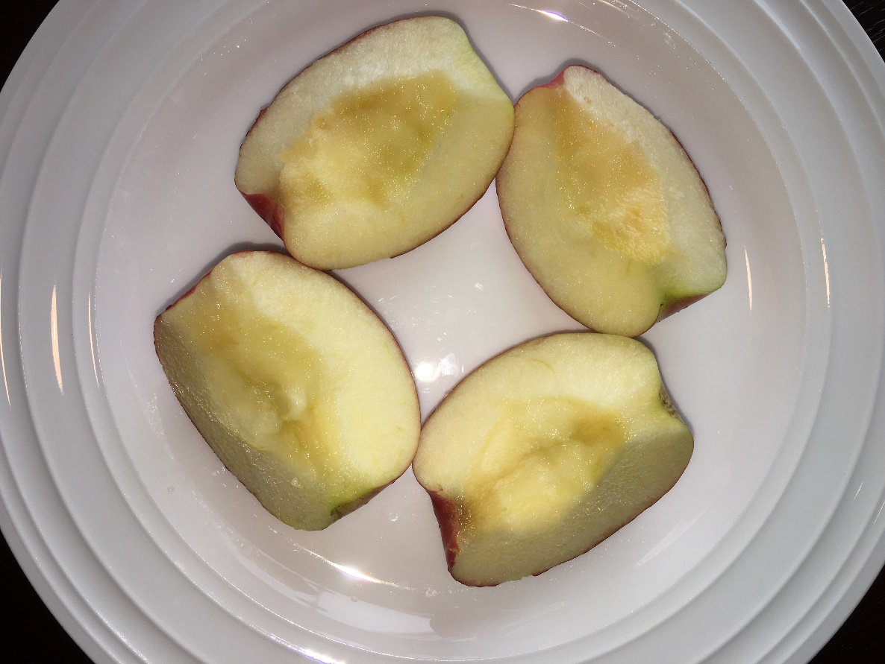

# How to Keep

# Your Apple Slices

# Healthy

Su Kara

Teacher: Dr. Eric Daniels

LePort Schools, Irvine Spectrum

Grade: 7

Presented at OCSEF

March 20-26, 2017

# Abstract

Apple slices turn brown over time because of the oxidation of the enzymes on their cut surfaces. You may dip them in certain solutions to prevent browning. Although they look less brown this may not necessarily mean that they’re healthy as well. I will investigate the microorganisms on apple slices after dipping them in different solutions, sealing in plastic bags, and refrigerating them for a week.

# Question

How can I keep apple slices healthy for a week?

# Hypothesis

Apple slices will stay the healthiest if I dip them in salt water and keep them in a sealed bag in refrigerator for a week. Salt will act as a general food preservative and the sealed bag will minimize contact with oxygen and prevent oxidation. Therefore, salt water and Ziploc should provide the best environment to keep the apple slices healthy.

# Background Research

When you cut an apple into slices, they soon turn brown. A process called oxidation takes place when a certain enzyme in the apple meets the oxygen in the air. This causes the apple surfaces to turn brown as well as dry out.

There are several techniques to minimize this oxidation process. Lemon juice is the most commonly used approach at homes. Simply squeezing some lemon juice in a small bowl of cold water, placing the apples inside for about fifteen minutes, and finally placing them inside a plastic bag is one way you can prevent oxidation.

Another way to prevent oxidation is to use salt water. Salt is a well-known food preservative as it sucks the water out of the food and doesn’t let microorganisms grow easily. It is heavily being used in the food industry to protect fresh food from spoiling.

The last technique I found interesting was using ginger ale or other carbonated drinks that contain small amounts of carbonic acid. Carbonic acid, which is a weak acid, forms two kinds of salts, the carbonates and the bicarbonates, which may keep apple slices fresh.

There are other ways, which I chose not to test in my experiment, to prevent oxidation like blanching, meaning to place the apples in a pot of boiling apples, to slide a rubber band around the apples right after cut, or using different products specifically made to prevent oxidation like Fruit-Fresh.

I decided I would like to make an experiment in which I would see, after seven days, which set of apples would look the freshest (ones soaked in lemon juice, salt water, or ginger ale). I also wanted to see the difference between the apples soaked in the same solution but some placed in a plastic bag, and the others let out in the open air of the fridge.

These were the most common ways to keep the fresh look of your apple slices, but there was no guarantee that they would also stay healthy at the same time. Therefore, I did some more research on what I could use to test the bacteria growth on each apple slice after seven days, and I found out about nutrient agar plates.

An agar plate is a Petri dish that tests the growth of microorganisms such as bacteria and fungus that grow on a surface. One can take a cotton swab (also known as a Q-Tip) and rub it on the tested object then streaks it on the agar plate. If the agar plate is left in a warm environment for a couple of days, they can see the colonies of bacteria on the dish. The dish with the least development of bacteria will prove to be the healthiest.

# Materials

|  |  |  |
| --- | --- | --- |
| * 6 apples | * Knife | * Cutting board |
| * Measuring cup | * 2 mixing spoons | * 3 bowls |
| * 1 tablespoon of salt | * 1 lemon | * Bottle of ginger ale |
| * Nitrile exam gloves | * 4 Ziploc bags | * 4 plates |
| * Tape | * Labels | * Permanent marker |
| * 8 nutrient agar plates | * 8 cotton swabs | * Refrigerator |

# Procedure

1) Prepare 3 bowls:

Bowl 1: Add 3 cups of water, one tablespoon of salt, and mix them.

Bowl 2: Add 3 cups of water, squeeze one lemon, and mix them.

Bowl 3: Add 3 cups of ginger ale.

2) Peel 6 apples, and slice each of them into 4 pieces to have 24 slices.

3) Build 8 groups of 3 apple slices from 24 slices:

Group 1: (Control Group) No dipping and leave open on a plate (Plate 1)

Group 2: No dipping and place in a sealed bag (Plate 1)

Group 3: Dip in salt water for 15 minutes and leave open on a plate (Plate 2)

Group 4: Dip in salt water for 15 minutes and place in a sealed bag (Plate 2)

Group 5: Dip in lemon juice for 15 minutes and leave open on a plate (Plate 3)

Group 6: Dip in lemon juice for 15 minutes and place in a sealed bag (Plate 3)

Group 7: Dip in ginger ale for 15 minutes and leave open on a plate (Plate 4)

Group 8: Dip in ginger ale for 15 minutes and place in a sealed bag (Plate 4)

4) Place the plates at the same level in the refrigerator, and leave for 7 days.

5) Label 8 agar plates, one for each group.

6) Allow agar plates to warm to room temperature for the agar surface to be smooth and moist.

7) Rub a cotton swab on the apple slices in each group separately, and swipe the swab across the surface of an agar plate labeled for that group.

8) Seal the plates and take them to the science lab at school.

9) Place the plates in the incubator, set the temperature to 87° Fahrenheit, and leave them in the incubator for 2 days.

10) Remove the plates from the incubator, open them, and observe the colonies of bacteria and fungus with naked eye.

11) Put the agar plates under a microscope, and examine the bacteria in a close-up view.

12) Dispose the used plates, swabs, and gloves as follows:

- Soak the used or contaminated material in a bleach solution (1 bleach:3 water) for 24 hours.

- Place the materials in the disposable bag and seal it.

- Incinerate the bag in the trash bin.

# Preparation Pictures

Preparing Apple Slices to Refrigerate:

|  |  |  |  |  |
| --- | --- | --- | --- | --- |
|  |  | |  | |
| Lemon Juice | Salt Water | | Ginger Ale | |
|  |  |  | |
| Solution Bowls | Fuji Apples | Peeling and Slicing | |
|  |  |  | |
| Apples in Lemon Juice | Apples in Salt Water | Apples in Ginger Ale | |

|  |  |  |
| --- | --- | --- |
|  |  |  |
| Ziploc Bags | Nitrile Exam Gloves | Sealing Process |

|  |
| --- |
|  |
| Refrigerate Apple Slices for 7 days |

After Removing Apple Slices from Refrigerator:

|  |  |
| --- | --- |
|  |  |
| Control Group (No Solution) | Ginger Ale |
|  |  |
| Salt Water | Lemon Juice |

Preparing Nutrient Agar Plates:

|  |  |
| --- | --- |
|  |  |
| Nutrient Agar Plates from Carolina Biomedical Supply Company | Swiping cotton swabs on apple slices and streaking zigzags on agar plates |
|  | |
| Agar plates ready to go to the science lab at school | |

Incubating Agar Plates to Grow Bacteria in the Science Lab at School:

|  |  |
| --- | --- |
|  |  |
| Incubator (front) | Incubator (top) |
|  |  |
| Incubator (inside top) | Incubator (inside angle) |

# Observation Pictures

Pictures of Agar Plates Under Naked Eye After 2 Days of Incubation:

|  |  |
| --- | --- |
|  |  |
| Ginger Ale, No Ziploc | Ginger Ale, Ziploc |
|  |  |
| Salt Water, Ziploc | Control Group |
|  |  |
| Lemon Juice, Ziploc | Lemon Juice, No Ziploc |
|  |  |
| Salt Water, No Ziploc | No Solution, Ziploc |

Pictures of Bacteria Colonies Under Microscope:

|  |  |
| --- | --- |
|  |  |
| Ginger Ale, No Ziploc | Ginger Ale, Ziploc |
|  |  |
| Salt Water, Ziploc | Control Group |
|  |  |
| Lemon Juice, Ziploc | Lemon Juice, No Ziploc |
|  |  |
| Salt Water, No Ziploc | No Solution, Ziploc |

# Data and Observations

As soon as the apple slices are removed from the refrigerator, you can visually observe two features: browning and dryness.

Table 1 below shows the apple slice groups in order of browning from highest (8) to lowest (1). In general, apple slices that were not kept in a sealed bag turned brown more than the ones that were in a Ziploc. Apple slices in the control group were the brownest, while the ones dipped into salt water and kept in a Ziploc were the best-looking ones with the lightest surface color. In general, all groups that were in Ziploc bags looked much better than the ones that were kept outside.

The surprising finding in this observation was that the second-best group of apple slices was not treated with any solution, but kept in a Ziploc. This finding shows that you can prevent your apple slices from turning brown just by putting them into a sealed bag. This will be very convenient and sufficient to avoid the oxidation of enzymes that cause browning since the bag will keep the surfaces of apple slices closed to oxygen.

|  |  |
| --- | --- |
| Apple Slice Group | Browning |
| Salt Water, Ziploc | 1 |
| No Solution, Ziploc | 2 |
| Ginger Ale, Ziploc | 3 |
| Lemon Juice, Ziploc | 4 |
| Salt Water, No Ziploc | 5 |
| Ginger Ale, No Ziploc | 6 |
| Lemon Juice, No Ziploc | 7 |
| Control Group | 8 |

Table 2. Browning (lowest to highest)

Table 2 below shows the apple slice groups in order of dryness from highest (8) to lowest (1). It is easy to notice that this table is identical with Table 1. Just like with browning, apple slices that were not kept in a sealed bag became dry much more than the ones that were in Ziploc bags. Apple slices in the control group were the driest, while the ones dipped into salt water and kept in a Ziploc were the best-looking ones with their fresh and watery surfaces. In general, all groups that were in Ziploc bags looked much better than the ones that were kept outside.

Since the experiment revealed identical results for browning and dryness, it can simply be claimed that apple slices should be kept in a sealed bag to protect from browning and dryness. Apple slices won’t contact oxygen, and they will stay fresh and watery regardless of getting treated in any solution before putting into a Ziploc.

|  |  |
| --- | --- |
| Apple Slice Group | Dryness |
| Salt Water, Ziploc | 1 |
| No Solution, Ziploc | 2 |
| Ginger Ale, Ziploc | 3 |
| Lemon Juice, Ziploc | 4 |
| Salt Water, No Ziploc | 5 |
| Ginger Ale, No Ziploc | 6 |
| Lemon Juice, No Ziploc | 7 |
| Control Group | 8 |

Table 2. Dryness (lowest to highest)

After removing the apple slices from the refrigerator, cotton swabs were swiped on the surfaces of apple slices and streaked onto agar plates. Then these plates were kept in an incubator at 87° Fahrenheit for two days. When they were removed from the incubator, bacteria growth was observed visually on the dishes.

Table 3 below shows the bacteria growth on apple slice groups from highest (8) to lowest (1). The healthiest apple slices were the ones treated by ginger ale, regardless of being kept in a sealed bag or not. In fact, the ones soaked into ginger ale and not kept in a Ziploc were healthier than the ones soaked into ginger ale and kept in a Ziploc.

I also made several surprising findings in this observation. First, apple slices that were not soaked into any solution and kept in a Ziploc showed the largest colonies of bacteria. In other words, it was the least healthy group even though it was the second best-looking one in the browning and dryness observations.

Another interesting finding was about the control group. Even though this group had the brownest and driest apple slices in my earlier observations, it was the fourth healthiest group despite the bad looks.

Finally, a sealed bag doesn’t guarantee that apple slices will stay healthy even though it keeps them looking fresh inside.

|  |  |
| --- | --- |
| Apple Slice Group | Bacteria |
| Ginger Ale, No Ziploc | 1 |
| Ginger Ale, Ziploc | 2 |
| Salt Water, Ziploc | 3 |
| Control Group | 4 |
| Lemon Juice, Ziploc | 5 |
| Lemon Juice, No Ziploc | 6 |
| Salt Water, No Ziploc | 7 |
| No Solution, Ziploc | 8 |

Table 3. Bacteria (lowest to highest)

# Graphs

Figure 1 below shows the browning of apple slices from lowest (1) to highest (8). Apple slices kept in salt water and a Ziploc had the lightest color, while the ones in the control group were the brownest.

Figure 1. Browning of Apple Slices (lowest to highest)

Figure 2 below shows the dryness of apple slices from lowest (1) to highest (8). Apple slices kept in salt water and a Ziploc looked the freshest, while the ones in the control group were the driest.

Figure 2. Dryness of Apple Slices (lowest to highest)

Figure 3 below shows the bacteria growth on apple slices from lowest (1) to highest (8). Apple slices kept in ginger ale and no Ziploc were the healthiest, while the apple slices kept in no solution and a Ziploc showed the largest bacteria growth.

Figure 3. Bacteria Growth on Apple Slices (lowest to highest)

# Conclusion

My hypothesis of dipping apple slices in salt water and keeping in a sealed bag to keep the apple slices the healthiest turned out to be wrong. I was expecting salt to be the best option as it’s being heavily used in the food industry as a preservative. Although it performed the best to prevent from browning and dryness, it only took the third place to keep the bacteria growth at a minimum. Meanwhile, ginger ale turned out to be the best choice to keep apple slices healthy.

Ginger ale commonly contains carbonated water, mix of spices, fruits, lemon, lime, and cane sugar. Pineapple and honey are also occasional ingredients. Ginger ale can also contain yeast, when carbonated with natural fermentation. This mixture that contained carbonic acid proved to be the best protector against microorganism development in a cold environment.

Although the control group (no solution, no Ziploc) performed the worst in the browning and dryness observations, it was the fourth healthiest group. This might be due to the dryness of apple slices. Fruits are usually dried to preserve them from spoiling, and apple slices protected themselves naturally by drying their cut surfaces. The same apple slices showed the highest bacteria growth when kept in a sealed bag because they couldn’t dry inside a Ziploc, and they were not soaked in a solution to protect them from microorganisms. Therefore, you should think twice before buying apple slices in a sealed bag at a grocery store.

The most important finding of this experiment is that browning of apple slices does not necessarily mean that they are spoiled. Likewise, keeping apple slices from browning and dryness doesn’t prove that they will stay healthy either. So, we shouldn’t be fooled by the looks of the apple slices. Instead, we should know how exactly they’re being protected.

In summary, if you want to keep your apple slices healthy, you should soak them in a carbonated drink such as ginger ale. If you also want to keep them from browning and getting dry, you should put them in a Ziploc. Even though ginger ale and Ziploc combination was the second healthiest option, for all practical purposes, it is the optimum choice. Keeping apple slices in a Ziploc will protect against contamination, and your apple slices will taste fresh and watery at the same time. So, ginger ale and Ziploc is the ultimate winner of this experiment.

# Acknowledgements

I’d like to thank Dr. Daniels, my science teacher, for helping me with the use of the hazardous materials, and letting me utilize the science laboratory to observe the results. I’d also like to thank my parents for supervising and providing the materials needed for this project.

# References

1. <http://www.sciencebuddies.org/science-fair-projects/project_ideas/FoodSci_p025.shtml>
2. <http://www.mcdonalds.ca/ca/en/food/your_questions_answered/produce_faqs.html>
3. <http://www.washingtoncitypaper.com/food/blog/13128398/just-how-fresh-are-mcdonalds-new-fresh-cut-happy-meal-apples>
4. <http://www.forbes.com/sites/nadiaarumugam/2013/09/30/the-best-thing-since-sliced-bread-sliced-apples-that-stay-fresh-for-weeks/#d48593970ad9>
5. <https://en.wikipedia.org/wiki/Carbonic_acid>
6. <http://www.momables.com/how-to-keep-apples-from-browning>
7. <http://www.theyummylife.com/prevent_apple_and_pear_slices_from_browning>
8. <http://www.wikihow.com/Keep-a-Cut-Apple-from-Turning-Brown>